Building for the Future
Leader's Guide to Planning for Recovery & Thriving

May 2020

Checklist to Return to Work
Consider the following dimensions, recognizing that your organization has specific requirements and staffing needs.
- Clarify what shifts you are making permanent:
Decide on what you are making permanent and establish clear priorities.
- Set workplace expectations & safety guidelines:
Publish New Working Agreements/Expectations. Establish clear expectations before shelter-in-place is lifted.
- Set customer safety guidelines:
Determine and communicate what your customer safety guidelines will be.
- Determine service hours & communication:
Establish scaled-back OR fully open hours. Update public communication materials that might communicate closure.
- Clarify staff support:
Establish a clear mechanism or method for staff to reach out with concerns, struggles, and special considerations. It’s critical to support staff as they settle back into regular operations.

Shifts You’re Making Permanent
This crisis has result in significant and positive shifts to our business model. Many of these forced shifts can be permanent because they are a better use of resources, improved quality of life for staff or enhances benefits for your customers. Consider which of the following you will make permanent.

Celebrate Adaptations
Celebrate those job functions that had been sent home but are now able to come back to work and those that worked in different capacities to serve a need in this crisis. What can you celebrate? Consider which workplace practices and job duties will be changed.

Flexible Schedules
Consider supporting continued telecommuting/working-from-home where appropriate. What will you make permanent?

Commit to Digital Delivery
Continue digital delivery of services and processes where the outcomes for customers and staff are improved. What will you make permanent? Understandably not everything can be remote/virtual, but are there areas where you can reduce costs, environmental footprint, and simplify for everyone? Where work can be electronic, and it should be?

Eliminate Non-Value Adds
Did you make reductions in extra, non-value-add steps in processes? What have you noticed? Are there non-value-add processes you could eliminate?
Worksheet - Strategic Roadmap to Adapt and Recover
Instructions: Modify and publish w/ your New Workplace Agreements.
MISSION…
STRATEGIC SHIFTS | STRATEGIC PRIORITIES | OUR FUTURE STATE
Lessons Learned | STABILIZING PHASE: When Shelter-in-Place lifted…Transition from a temporary environment to permanent.  - X  - Y  - Z  - A  - B | In 2 years, we will have rebounded to something better, which looks like…
Shifts we are making Permanent | DEFINE OUR NEW NORMAL PHASE:  People & Budget are stabilized for a few months, then…
FUTURE LOOKING PHASE:
The new normal is normal. We can invest & innovate.

Resetting Work Agreements & Norms
This crisis is forcing us to re-create our working agreements. Instead of assuming your organization is reverting back to pre-pandemic working environments, you need to clearly and deliberately reset your expectations.

#1 Establish Your Flexible Work Policy
Here are some prompting questions to answer as you create policies related to flexible/remote work. Most importantly: be clear and consistent. Remind staff flexible schedules are a privilege.
- Work/Telework: Can your employees work a set number of hours/weeks remotely? What is the process of staggering remote employees with in-office employees? Is there a schedule to be implemented that outlines which employees are working from where every week?
- Flexible Schedules: Are employees allowed to shift their schedules from the traditional hours of 9a-5p? Do you have a standard set of “bodies in front of desks” hours? Are employees allowed to request non-traditional hours and what is the process to do so?
- Compressed Workweek: Can employees opt to work fewer longer days to enjoy an extra “weekend” day? What is the process for approving these requests?
- PTO: What is the policy on PTO? Are employees allowed to take 1/2 days off without using PTO, or are the required to submit a PTO request if 1/2 day or more?? What is the process for requesting/approving PTO requests?
- Expanded Leave: What is the policy on expanded leave if an employee gets sick, needs to care for a family member, take a sabbatical, or pursue education? What is the approval process?
- Work and Family Programs: How are you supporting employees that need flexibility for childcare? What is the process for requesting and approving these schedules?

#2 Determine How You’ll Bring Employees Back
Consider staggering employees’ return and continue social distancing, travel restrictions and remote work support.
- Slow re-entry: Consider leaving employees at home or delaying when you bring people back.
- Shift re-entry: Bring employees back to work in stages. Schedule employees in shifts.
- Reduce business travel: Maintain restrictions on noncritical travel and define what is/isn’t critical.
- Provide a care package: Provide every employee with wipes and a mask.

#3 Reconfigure Your Physical Workspace
Rethink and reconfigure your physical workspace with the following guidelines. Here are some good visuals from WeWork.
- Increase cleaning: Maintain/increase cleaning schedule for facilities and continue hygiene procedures.
- Smaller meetings: Limit the number of people attending in-person meetings.
- Move desks: Increase physical distance between individual workspaces.
- Remove chairs: In conference rooms, leave one seat between each person. Designate which chairs are to be left empty or remove chairs in shared spaces.
- Enforce 6-foot distance: Mark the floor in areas where staff or customers need to maintain 6 feet of distance. Think about 6 feet in terms of a yoga mat or a full arm span.

#4 Establish Workplace Safety Policies
Make it comfortable and clear that practices around social distancing, mask-wearing and shared space cleaning are the norm and expected. OSHA identifies the following job risk categories – Low, Medium, and High. https://www.cdc.gov/coronavirus/2019-ncov/community/guidance-business-response.html
- Low Risk: Jobs have no or infrequent close contact (within 6 feet) of people when it is unknown if they are Covid-19 positive (“the general public”). Personal Protective Equipment (PPE)is not recommended in low risk jobs.
- Medium Risk: Jobs that require frequent or close contact (within 6 feet) with the general public. Additional PPE may be recommended.
- High Risk: Jobs that require frequent close contact with individuals who are known or suspected to be infected with Covid-19. PPE is Recommended.

Here are some guidelines:
- Wear masks: Be clear about expectations and norms for masks Consider wearing masks when interacting with other staff members, but not when working alone at a desk.
- Wipe down shared spaces: Standardize post-meeting clean up–if you use a conference room, you’re responsible for wiping down after.
- Use personal utensils & cups: Eliminate the use of shared kitchen utensils unless you have a dishwasher. Eliminate office water and coffee cups unless you have a dishwasher.
- Mark off-limits chairs: Mark lounge chairs with tape or other indicators that show these are off limits to honor social distancing.
- Consider temperature checks: Manage temperature checks and travel histories for office visitors. This is currently legal but watch the Federal guidelines for changes.
- Post your policy for all to see: Board members, customers, visitors, etc.
Give your revised agreement a few weeks and then come back as a team to check in and see how the new arrangement is working.

Tips to Help Staff Transition Back to Work

Keep Up the Communication
Being back physically in the same space doesn’t mean communication levels should drop. Take your new proactive communication skills back to the office.

Establish "Focus Time" Boundaries
After working from home where it's (probably) quieter than your office, it may be frustrating to constantly have coworkers dropping by to chat. Block out time for uninterrupted focus and find a way to communicate those times to your coworkers or designate and use a quiet room.

Make Your Desk Feel Like Home
If you discovered a favorite coffee mug during your WFH time, it back to the office with you. Ditto for a blanket to be more comfortable, or a particular desk chair you prefer. Stock your desk drawer with easy-to-reach snacks.

Stick to Your Routine
If you got in the habit of working out early in the morning or taking mid-day walks, make the time during your in-office workday for it. If you're in the habit of checking email first thing in the morning with a cup of coffee, don't feel the need to switch it up with a return to the office.

Learn to Enjoy Your Commute
The best part of WFH may have been losing your commute. Instead of resenting your commute when transitioning back to the office, figure out a way to be productive or enjoy the time: knock out calls with coworkers (that don't require computer screens), listen to a podcast, or simply enjoy some quiet time for reflection while commuting.
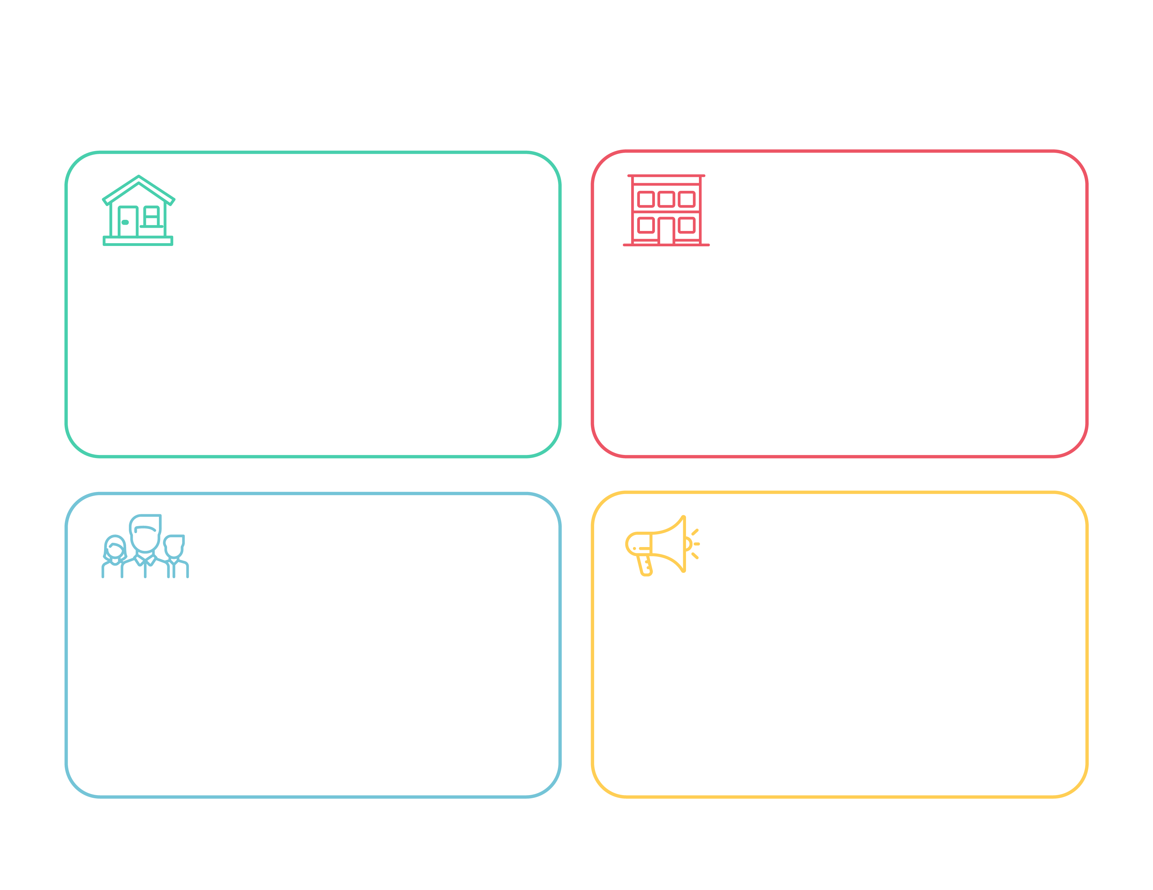
- Practice social distancing: stay 6 feet away from others.
- Take your temperature. Any temperature above 100.4 F is considered a fever and should prompt you to go home/to the doctor immediately.
- Enhanced hygiene standards: wash hands often; sneeze/cough into a tissue or elbow.
- Speak up if something is needed or you see an opportunity to enhance safety.
- Respect others’ health and wellness.
- Take care of yourself by getting good sleep, walking and/or exercising.
- Patience! Things are changing rapidly.
- Pick up the phone. If more than 2 email exchanges or more than a few moments chatting on Teams, make a call to finish the conversation or walk to the other person’s desk for a friendly face-to-face (6’ apart).
- Results & deliverables matter more than “showing up.”
- Be accountable for results. “Check out” daily with your manager sharing what you accomplished/completed.
- Be intentional about when you hand off to your colleagues: communicate that you’re done with your share, where you left off, where they can find what you’ve completed.
- Masks should be worn when meeting or walking in a shared space. Masks are optional while working alone at your desk.
- In conference rooms, leave one seat between each person.
- You reserve it, you wipe it. If you reserve a conference room, you have the responsibility to wipe down all surfaces after your meeting.
- Help keep your office/desk safe: sanitize regularly and reduce the clutter so fewer surfaces where virus can live.
- If possible, avoid guest and visitors. Limit congregation in any spaces.
- Eliminate trips outside the office. Bring food or have lunch delivered.
- Show up in the office 3 out of 5 days per week.
- Have a regular schedule when you’re WFH and when you’re in the office that is the same every week.
- When WFH, keep some structure to your schedule, workspace and work: leave the household chores for before/after work.
- Working from home = being “present” on Teams.
- Don’t go ‘radio silent.’ When WFH, proactively communicate with your coworkers via Teams, phone and email.

How to Communicate Effectively…

When You Are Working at the Office…

When You Are Working at Home…

How to Share Spaces in the Office…

Instructions: Below are possible policies based on the guidelines provided above. Modify and publish. Delete line this when complete.

