A Free Guide to Establish a Quarterly OKR Cycle
The expectation to run teams and organizations in a more agile, fluid manner is continuing to grow and become the norm, not the rule. The best part of the growing popularity of OKRs (Objectives & Key Results) is how this practice creates agility because it's based on managing and planning in quarterly increments.
As we’ve noted in other guides, OKRs are all the rage, made popular by Google, as a methodology for goal setting and driving accountability throughout high-growth organizations. While you may not be using OKRs specifically, you can adopt the agile process of establishing a quarterly rhythm.
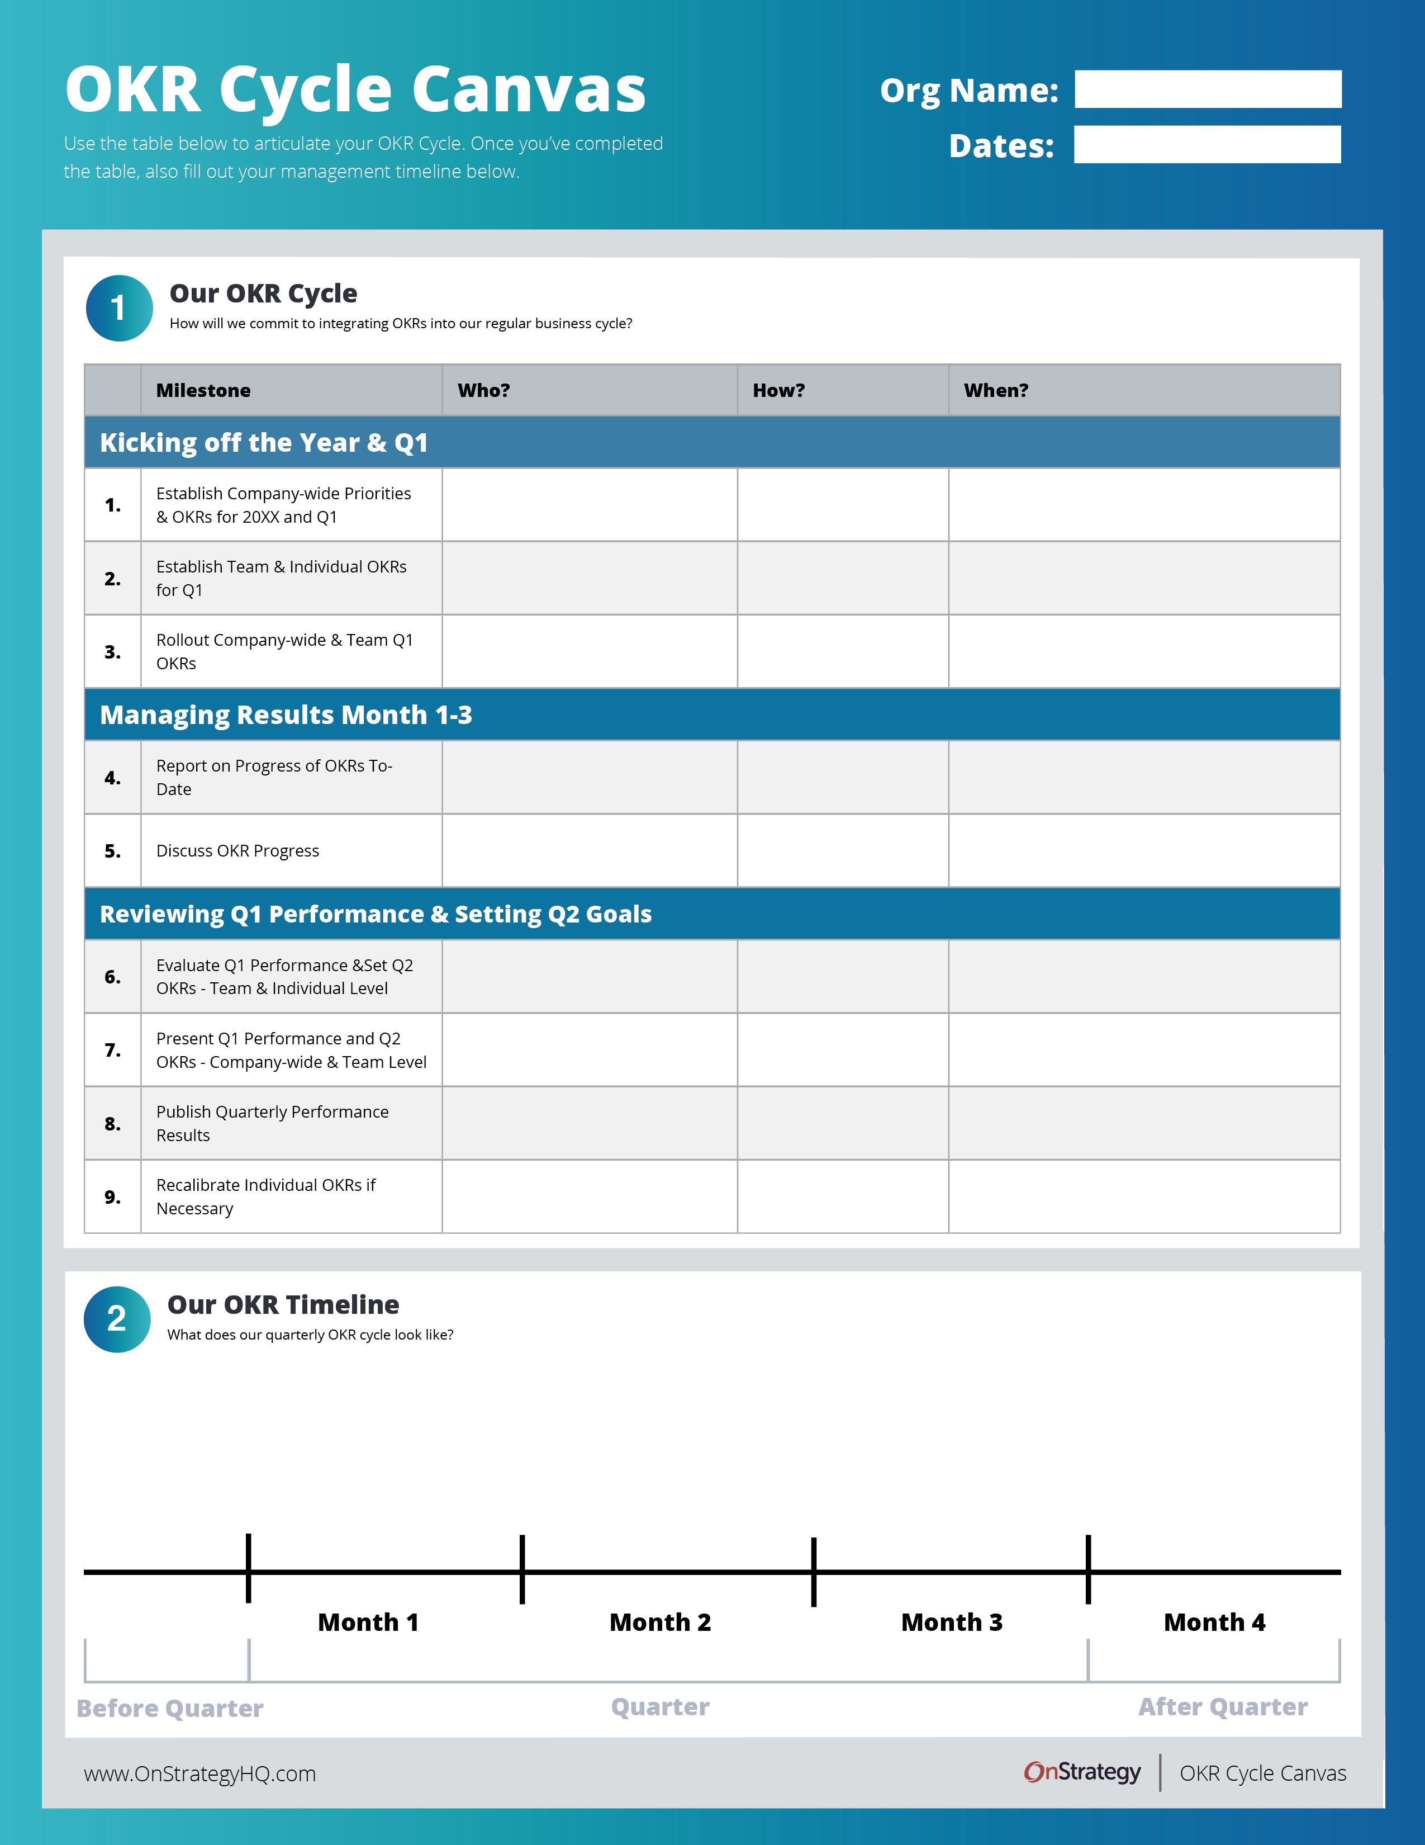

<CTA> Download the Guide <CTA>

<h2> A Quarterly Process <h2>
Driving agility comes from the management cycle of revising results and refreshing goals quarterly, with annual company-wide priorities backed by monthly progress reporting.

<h3> What increment is best for you? <h3>
Our best practice is to fit the management rhythm with organizational pace and market demands. You’ll know which one is right for you! Here are the most common options for the increments for which you can manage a plan:
- Weekly: Starting with the shortest time period, weekly reviews shouldn’t just be focused on OKRs. Instead, we recommend integrating a component of the OKR review process into your regularly scheduled weekly tactical meetings. These weekly tactical meetings cover the operational elements and weekly priorities of your team, their activities, and what needs to be accomplished during the next 5-7 days.
- Monthly: Monthly reviews are purpose-built sessions to review the performance of your OKRs and decide what are the critical actions you need address in the next 30 days.
- Quarterly: Quarterly reviews are sessions designed to review your performance and articulate focus for the next 90 days. We consider quarterly strategy reviews table stakes when it comes to the OKR process. The absence of quarterly strategy reviews is a surefire way to lose focus on how your organization is trending towards its goals, quarterly, annually, and long-term.
- Annual: Annual reviews are designed to look back on performance of your team during the past 12 months and articulate the bigger focus for the coming 12 months. This is the most traditional planning sequence. We still recommend leveraging this cycle, but it should be accompanied by another review sequence.

<h3> Don’t Over-Plan <h3>
Once you've determined the increment for which you want to manage against your OKRs, you’ll need to work with your Executive Team to set annual company-wide Goals/Objectives. Then, work with their teams to set quarterly Key Results/Deliverables. You can read about how to create OKRs here!
Measuring the performance of Key Results is [traditionally] assessed quarterly. The next quarter’s Key Results should be set based on your previous performance and emerging themes.
The purpose behind this is to create agility and not “over-plan” work. Instead, you’re planning and managing results quarterly which helps create a more exciting and dynamic goal setting practice than setting annual goals you forget about.

<h2> A Typical OKR Cycle <h2>

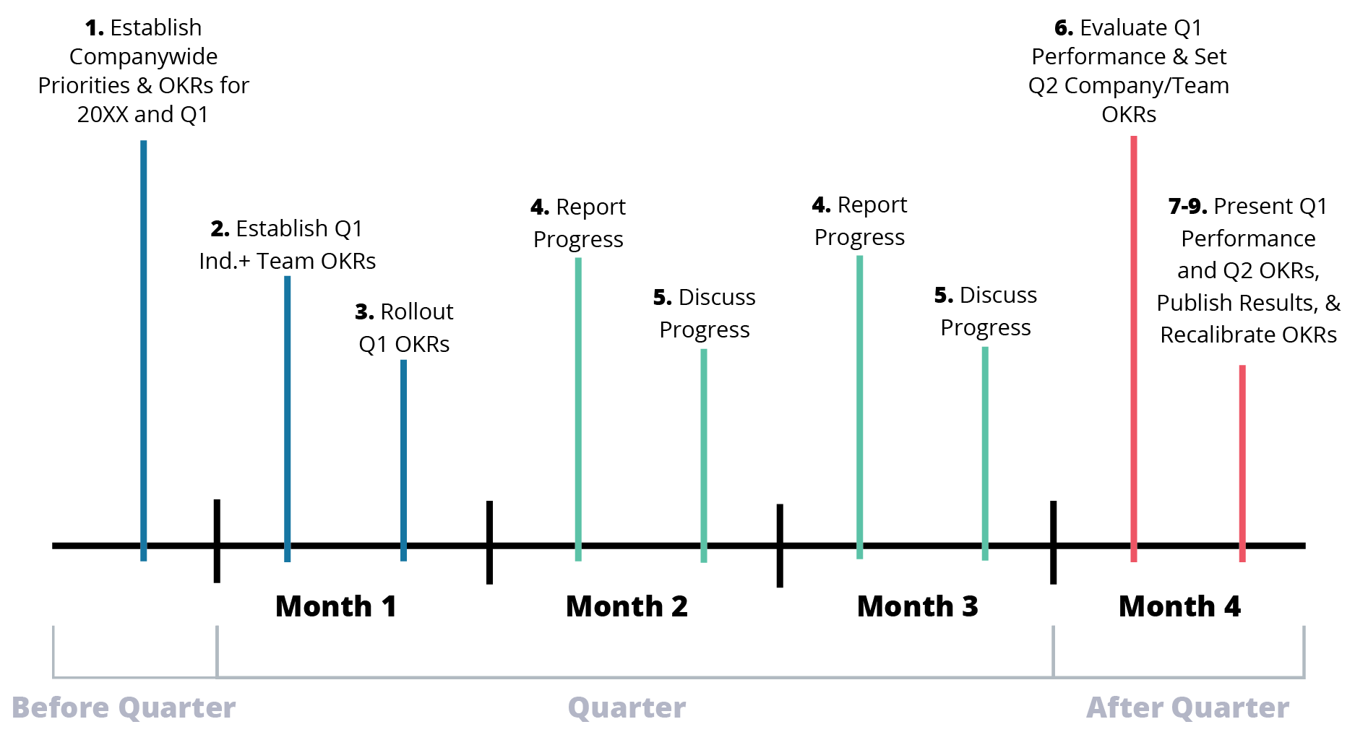
Above is an illustration of a standard quarterly cycle. To make this work for you, here are a few questions to answer. Use your answers and the worksheet in the free guide to build a quarterly process that will fit your team.
- What system or tool will you use to capture and manage OKRs?
- Will monthly check ins be conducted as part of 1:1s or included in your monthly staff meeting?
- Will your Business Review be monthly or quarterly? Will it be part of an existing meeting or a new meeting?
- Do you want to include dedicate time for strategic topics at your Monthly/Quarterly Business Review or will those be handled at different meetings?

<h2> Step-by-Step OKR Cycle <h2>
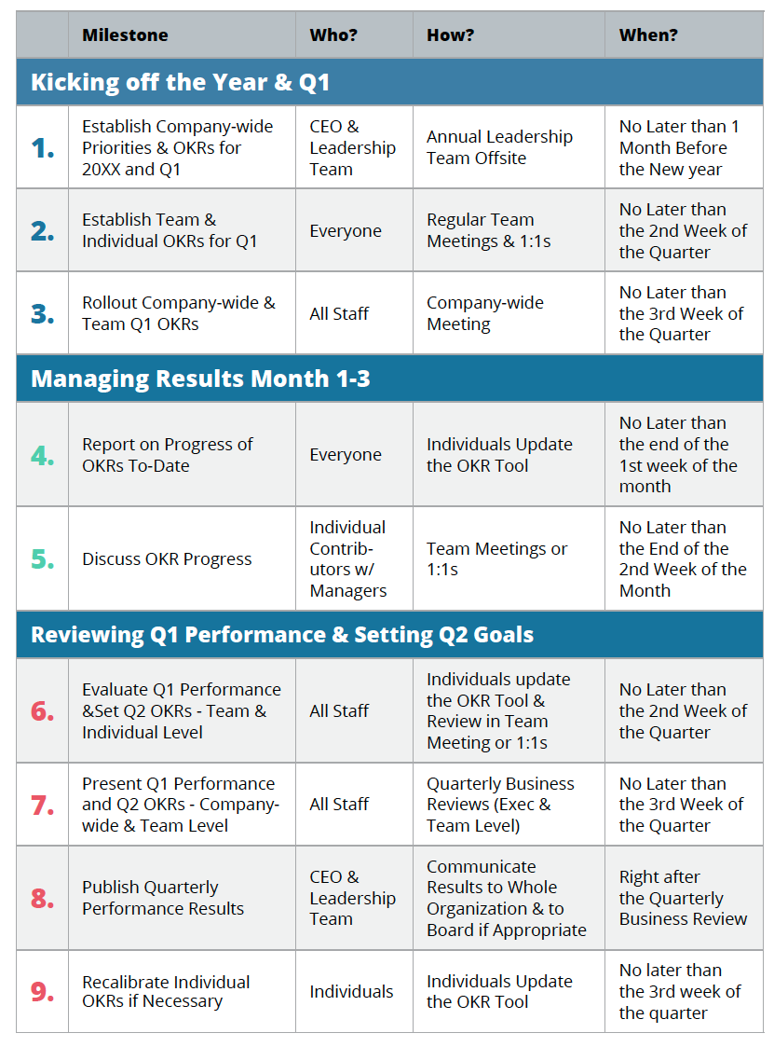

 | Milestone | Who? | How? | When?
 | Kicking off the Year & Q1
1. | Establish Company-wide Priorities & OKRs for 20XX and Q1 | CEO & Leadership Team | Annual Leadership Team Offsite | No later than 1 month before the new year
2. | Establish Team & Individual OKRs for Q1 | Everyone | Regular Team Meetings & 1:1s | No later than the 2nd week of the quarter
3. | Rollout Company-wide & Team Q1 OKRs | All Staff | Company-wide Meeting | No later than the 3rd week of the quarter
 | Managing Results Month 1 - 3
4. | Report on progress of OKRs to date | Everyone | Individuals update the OKR Tool | No later than the end of the 1st week of the month
5. | Discuss OKR Progress | Individual Contributors w/ Managers | Team Meetings or 1:1s | No later than the end of the 2nd week of the month
 | Reviewing Q1 Performance & Setting Q2 Goals
6. | Evaluate Q1 Performance & set Q2 OKRs - Team & Individual Level | All Staff | Individuals update the OKR Tool & Review in Team Meeting or 1:1s | No later than the 2nd week of the quarter
7. | Present Q1 Performance and Q2 OKRs - Company-wide & Team Level | All Staff | Quarterly Business Reviews (Exec & Team Level) | No later than the 3rd week of the quarter
8. | Publish Quarterly Performance Results | CEO & Leadership Team | Communicate results to whole organization & to Board if appropriate | Right after the Quarterly Business Review
9. | Recalibrate individual OKRs if necessary | Individuals | Individuals update the OKR Tool | No later than the 3rd week of the quarter

<h3>3 OKR Management Pro-Tips<h3>
We know the “pro” of this approach is building agility into your organization. The “con” is the process can buckle under its own weight if not managed simply and seamlessly. Here are a few tips:
- Rigorous Consistency: Establish the cycle and dates for the year. Publish them and commit. Do not cancel meetings.
- Company-wide Visibility: Not only do you want to discuss results at a team or company-wide meeting, you also want to publish results physically via dashboards or other reporting mechanisms.
- “Aspirational” Commitments: As a team, you win and lose together. The act of making quarterly commitments (via setting individual OKRs) and reporting on them can feel punitive. Remember that achieving around 70% of key results is the idea. In other words, some “reds” and “yellows” are OK.

<h2> How to Report on Performance & Plan Simultaneously<h2>
The trickiest part of streamlining an OKR cycle is reporting on performance and establishing the next quarter's goals at one time. Here is how we think about this process to make this easy. For every key result, goal or initiative, think about the three "C's:
- Close Out: Close out the key result by reporting on the actual progress or metric achieved at the end of the third month.
- Carry Forward: Determine if this key result will continue into the next quarter. If so, extend the end date to the end of the third month and establish the desired target.
- Create New: Determine if any new key results need to be established to achieve the objective. If so, write new key results; establish the target and set the end date for the end of the third month.
For whatever OKR software tool you are using, you need to output the Performance Report for the previous quarter and the Action Plan for the upcoming quarter.
<h3> Refreshing OKRs Pro-Tip <h3>
While we are “refreshing” our goals and objectives every quarter, what happens most of the time you will carry forward the objective and most of the key results (specifically quantifiable outcomes).What you will “refresh” is establishing the target for the next quarter and likely new key results that are efforts or initiatives.

<h2> Running a Great Monthly/Quarterly Business Review <h2>
The heartbeat of a productive Goal/OKR Cycle is a Monthly or Quarterly Business or Strategy Review. There are many different ways to run this meeting, however here is a tried and true agenda start with and evolve to your culture.
- Time Allocation: Monthly for 60 mins or Quarterly for 2 hours.
- Attendees: Executive Team or Directs if running a team review.
- Preparation: All Goals/OKRs have current performance data through the end of the quarter.
- Purpose: To review company-wide performance goals/OKRs driving Strategic Priorities and calibrate focus for upcoming quarter. (NOTE: This meeting is NOT public shaming for non-performance. That is handled in 1:1s, of course.)

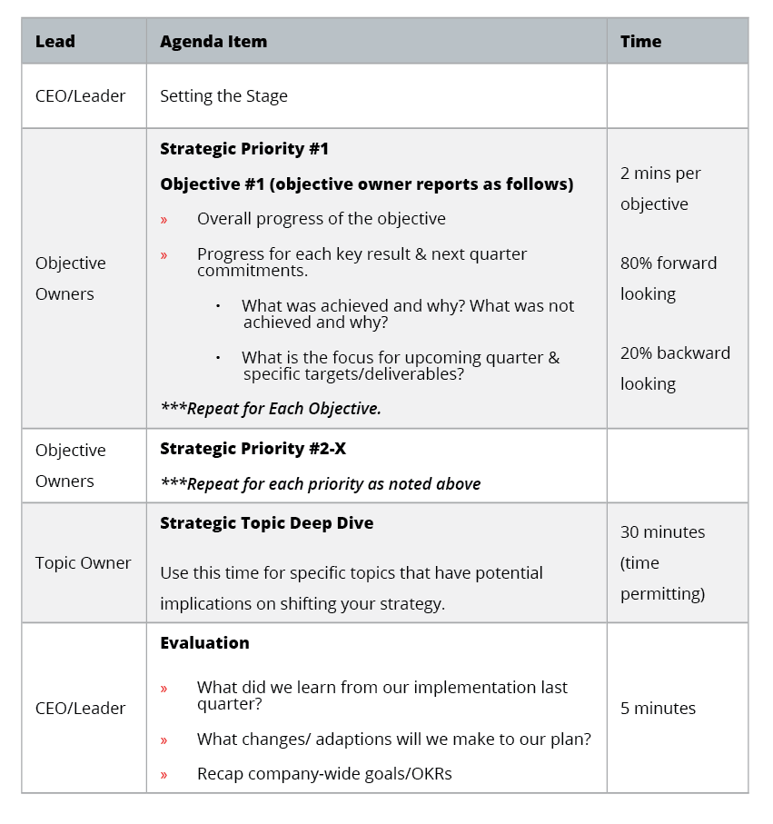

Lead | Agenda Item | Time Allocation
CEO/Leader | Setting the Stage
Objective Owners | Strategic Priority #1  Objective #1 (objective owner reports as follows)  · Overall progress of the objective  · Progress for each key result & next quarter commitments  o What was achieved and why? What was not achieved and why?  o What is the focus for upcoming quarter & specific targets/deliverables?  Repeat for each objectiv | 2 mins per objective, 80% forward looking, 20% backward looking
Objective Owners | Strategic Priority #2 - X  Repeat for each priority as noted above
Topic Owner | Strategic Topic Deep Dive  Use this time for specific topics that have potential implications on shifting your strategy. | 30 mins  (Time Permitting)
CEO/Leader | Evaluation  · What did we learn from our implementation last quarter?  · What changes/ adaptions will we make to our plan?  · Recap company-wide goals/OKRs | 5 mins

<h2> Using the OS App to Manage your OKRs <h2>
The OnStrategy Team built our application to holistically and easily manage organizational, team and individual performance. Built into our code is the philosophical approach noted above. You can easily:
- See a quick view of your team’s performance.
- Collect performance updates in 15 minutes or less.
- Automagically see company-wide performance and pre-built dashboard to run quarterly reviews.
- Everyone on the team can see how they contribute to the bigger picture.
- Quickly refresh and reset OKRs quarterly.

Click here to talk to a Senior Strategist to look under the hood!

Canvas

<CTA> Download the Guide <CTA>
WWUT

Roadmapping an Organization’s Structure to Reduce the Burden of Cancer

The Challenge:
Although a small and nimble team, the Nevada Cancer Coalition (NCC) needed to evolve their organizational structure to best serve the needs of the Nevadans in the areas of cancer prevention, early detection, treatment, and surviving cancer-free.

How We’re Supporting the Nevada Cancer Coalition:
Lorna Shepard and our team are supporting the Nevada Cancer Coalition as they plan for the organization they need for the future, including how they might structure and grow their team, how they can capitalize on their strengths, and where they need to deepen their services and impact.

Their Impact:
NCC aims to improve the health of Nevadans through cancer prevention and early detection, education, and advocacy.

The foundation of any great plan starts with understanding where you are today and defining where you want to be in the future. But, sometimes defining where you want to be in the future requires building an organization that can grow into that future. It’s no secret that sometimes you need to shift and change organizationally to meet your desired future state.

The Nevada Cancer Coalition (NCC) is a small — yet mighty — organization that makes a serious impact tackling the growing need for cancer prevention, early detection, treatment, and survivorship in Nevada.

As the need for these critical services continues to grow, NCC enlisted our help to develop a strategic plan and organization roadmap to clearly dictate their goals and how they should scale their team structure to achieve those goals. Here are a few great questions and prompts we used during this facilitation that might help your planning team as you build your own plan:

- Do you have the resources or staff required to achieve your vision and long-term goals? Think about how your plan and organization impact each other.

- Where do you need to grow as a team? Can you develop your current team to meet your needs, or do you need to add more expertise?

- If you need to change your organization structure, how long might that take? How might that impact your long-term goals?

Working with the dedicated team at NCC was a refreshing and compelling experience. It’s always wonderful to work with a team that’s dedicated to their work and we can’t wait to see how they grow and transform to combat cancer in our state. Wonderful work, Nevada Cancer Coalition!

SUBJECT LINE: A Free Guide to Establish a Quarterly OKR Cycle

LATEST INSIGHT
A Free Guide to Establish a Quarterly OKR Cycle
Check out our free guide and canvas to help your team develop a quarterly cadence to manage your OKRs/goals.

WWUT
Roadmapping an Organization’s Structure to Reduce the Burden of Cancer

Read how we’re helping the Nevada Cancer Coalition evolve their organizational structure to grow into their desired future state.

IN CASE YOU MISSED IT

Can You Say What Your Strategy Is? A Free Guide to Storyboard Your Strategy.
Can your team summarize your company’s strategy? Leverage this free downloadable guide to help your team review and storyboard the three core components of your organization’s strategy.

A Free Downloadable Guide for Setting OKRs that Work
Get the free guide and canvas to learn how you can leverage the OKR (objective and key result) model for goal setting and accountability that was popularized by Google.

CTA – SAME
GIVE BACK – SAME

VIDEO - https://onstrategyhq.com/resources/video-what-are-okrs-obective-and-key-results/

