People understand information differently and we understand that.

Here are the MyStrategicPlan reports – find what works for you.

Find and consider inserting old table showing report options…

Plan Only Reports
One Page Plan View Sample  An easy-to-read, full-color overview of your strategic plan. Great way to visualize your strategy. Often printed poster size and posted where everyone can see it. | 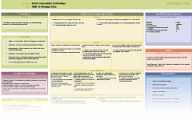
Linear Cascade View View Sample  A linear representation of your plan to show alignment from your strategic objectives to individual actions. Ideal for communicating your plan to the entire organization. We love this report! | 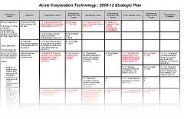
Full Strategic Plan View Sample  A report of your strategic plan from mission statement through action items. | 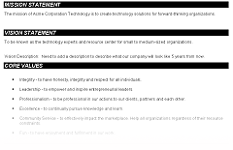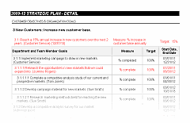
One-Click Report View Sample  Everything included. A comprehensive look at your plan from mission statement through actions items and includes SWOT, Scorecard, Roadmap and Budget. | 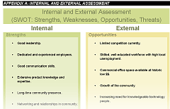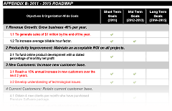
Executive Summary View Sample  A summary of your strategic plan with strategic objectives and goals but without action items. Good for management teams and boards. | 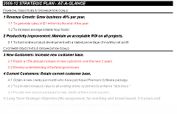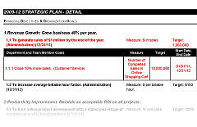
Road Map View View Sample  A summary of high level goals broken out by year according to the dates established during goal creation. | 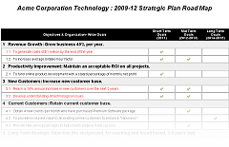
SWOT View Sample  An assessment of your organization’s strengths, weaknesses, opportunities and threats reflected in a single document. | 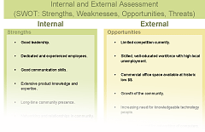
Plan Reports with Progress
Full Strategic Plan (with Progress) View Sample  A report of your strategic plan from mission statement through action items. Includes a progress at a glance summary as well as status and comments of all the goals and actions. | 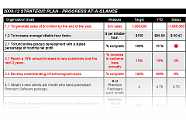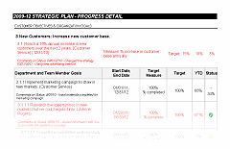
Executive Summary (with Progress) View Sample  A summary of your plan with strategic objectives and goals but without action items. Good for management teams and boards. Includes status and comments of all the goals and actions. | 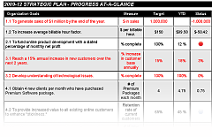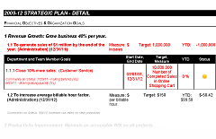
Scorecard View Sample  An overview of your KPIs, measurements, and targets with dedicated fields to track both year-to-date and monthly progress. | 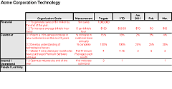
Action Plan View Sample  Quick hit summary of goals and action items for every person on your team. Includes comments, due dates and status. | 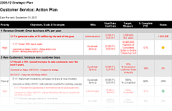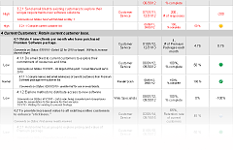
Budget Report View Sample  A review of all revenue and expenses associated with your goals and actions to determine if your plan makes financial sense. | 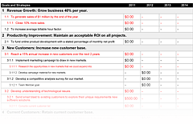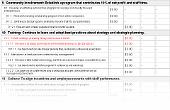
Performance Review View Sample  Use the action plan as a performance review sheet for your periodic staff reviews. | 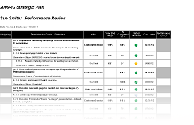
Add-on Feature
Strategy Dashboard View Sample  As an effective addition to your strategy planning this interactive dashboard gives rich visualization for targeted execution and management.  Stay on track with quick, accessible overviews and detail that lessens need for downloads and paper-based reporting. |  | 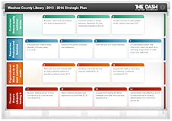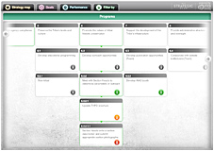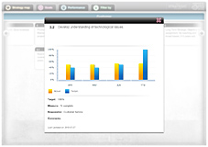
*If you would like to discuss these report options further, please call 775-747-7407.

