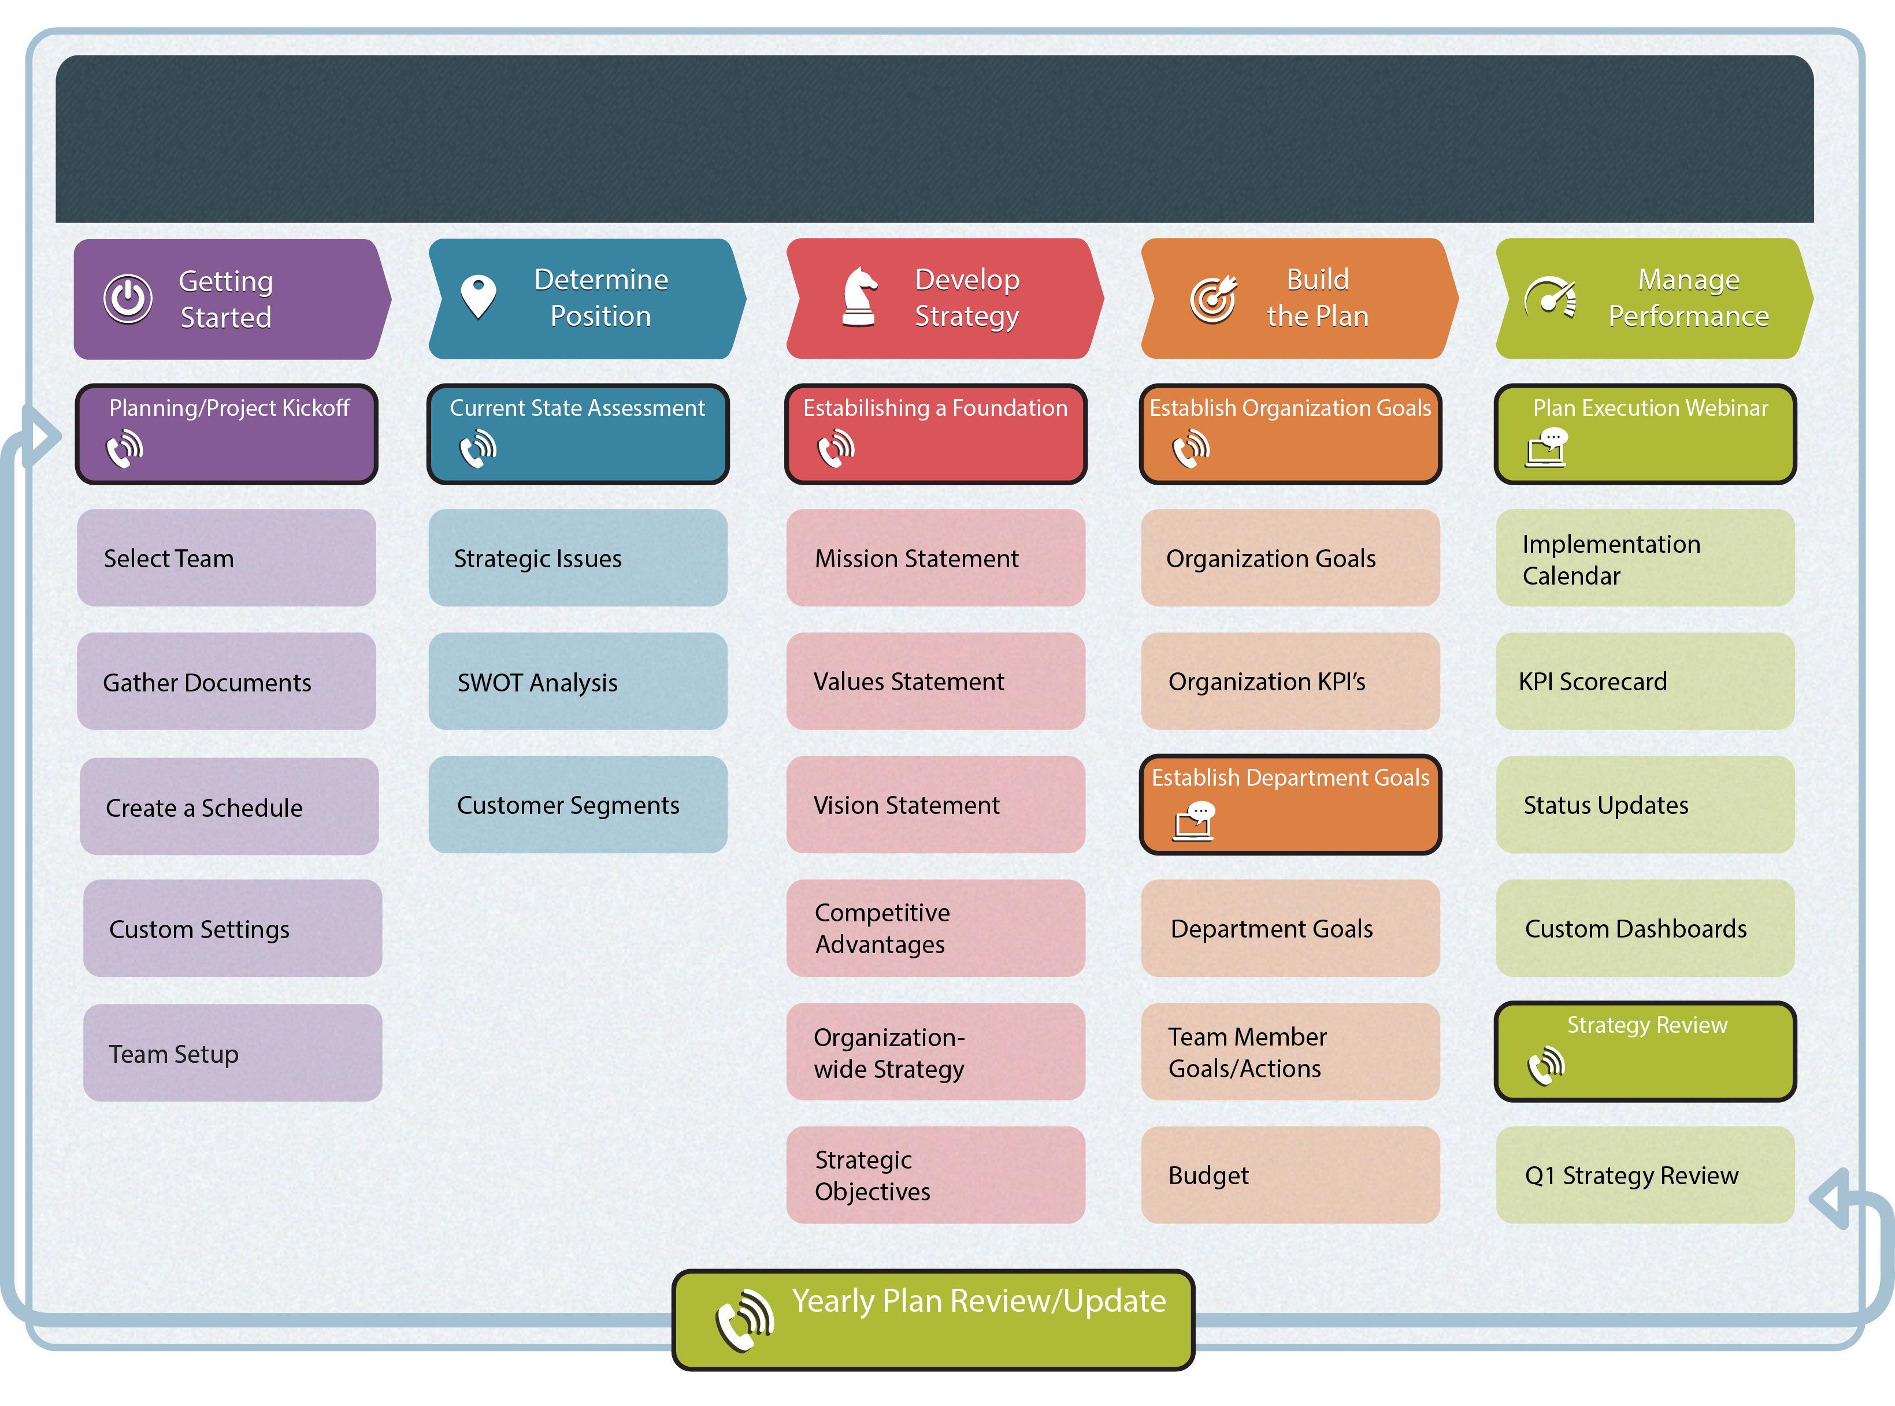

<Insert Date>

<Insert Date>

<Insert Date>

<Insert Date>

<Insert Date>

<Insert Date>

<Insert Date>

<Insert Date>

**<Org Name >’s Planning Process**